
Blockchain-Based Transparent Donation Platform


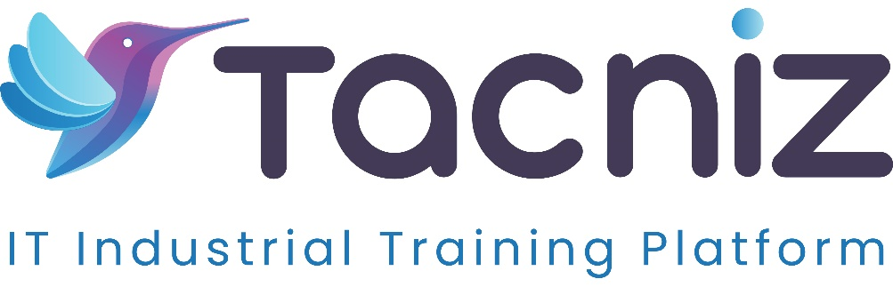

Problem Statement
Transparency and accountability are major concerns in charitable donations. Donors often lack visibility into how their contributions are allocated and used, which can reduce trust and discourage future donations. A Blockchain-Based Transparent Donation Platform addresses this issue by leveraging blockchain technology to create a transparent, traceable donation process. This ensures that funds reach the intended causes and allows donors to track the impact of their contributions in real-time, enhancing trust and encouraging continued support.

Project Type
- Type: Web and Mobile Application
- Category: Donation and Charity Platform, Blockchain Transparency

Industry Area
- Industry: Nonprofit, FinTech, Social Good, Blockchain Technology
Relevant Sectors: Charitable Giving, Social Impact, Financial Transparency, Blockchain for Good

Software Expertise Required
The development of a transparent donation platform using blockchain requires several technical skills and tools:
- Blockchain Development: Proficiency in blockchain platforms like Ethereum, Hyperledger, or Binance Smart Chain to create smart contracts that securely manage and track donations. Smart contracts enable traceability and automate fund distribution.
- Frontend Development: Experience with React, Angular, or Vue for creating a user-friendly web interface, and React Native or Flutter for mobile applications to make the platform accessible on multiple devices.
- Backend Development: Skills in Node.js or Django for handling server-side operations, integrating blockchain data, and managing user information.
- Smart Contract Programming: Expertise in Solidity (for Ethereum) or another smart contract language to develop secure, immutable contracts that track donation transactions.
- Database Management: Use of databases like MongoDB or PostgreSQL to store non-sensitive user data and transaction metadata, ensuring efficient retrieval and processing.
- API Integration: Integration with blockchain APIs (e.g., Etherscan, Binance API) for real-time updates on transaction status, and integration with social media platforms for donor recognition.
- Security & Compliance: Deep knowledge of data security and compliance standards, especially for handling sensitive financial information, to ensure the platform adheres to privacy regulations.

Use Cases
- For Donors: Individuals and organizations can donate to specific causes or charities, track their donations in real-time on the blockchain, and receive updates on how their funds are being utilized.
- For Charities and Nonprofits: Charities can use the platform to receive donations transparently, build trust with donors, and showcase progress on their projects.
- For Social Impact Organizations: Organizations focused on social good can leverage the platform to demonstrate transparency and increase donor engagement through detailed project tracking.
- For Corporate CSR Programs: Companies can manage their corporate social responsibility (CSR) donations and monitor the impact, improving accountability and reporting to stakeholders.

Expected Outcomes
The platform will create a transparent, secure donation experience, where donors can see exactly how their contributions are used. By tracking donations through blockchain, the platform provides an immutable record of transactions, giving donors peace of mind and encouraging greater participation in charitable activities. Charities benefit from increased donor trust, potentially leading to more consistent and impactful funding.

Benefits
- Enhanced Transparency and Trust: The use of blockchain technology ensures that all donation transactions are traceable, verifiable, and immutable, which builds trust with donors.
- Real-Time Updates: Donors receive real-time notifications on the progress of the projects they support, reinforcing their connection to the cause.
- Accountability for Charities: Charities are held accountable for funds received, as all transactions are publicly accessible, which can improve reputation and donor loyalty.
- Increased Donor Engagement: The platform’s ability to track donations and provide updates encourages donors to stay involved and promotes recurring donations.
- Donor Recognition: Donors can receive recognition on the platform, which can be shared on social media, increasing visibility for both the donor and the cause.
- Improved Efficiency in Fund Allocation: Smart contracts can automatically allocate funds to specific needs, reducing administrative overhead and ensuring that donations are used effectively.

Project Duration
- Estimated Duration: 5-6 months to develop, test, and deploy a fully functional version, including smart contract development, user interface design, and rigorous security testing.

